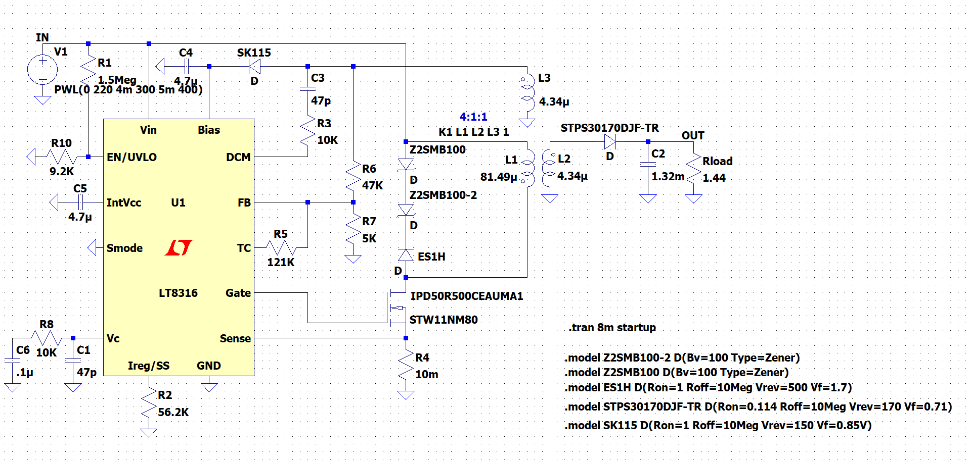

Figure Circuit Diagram

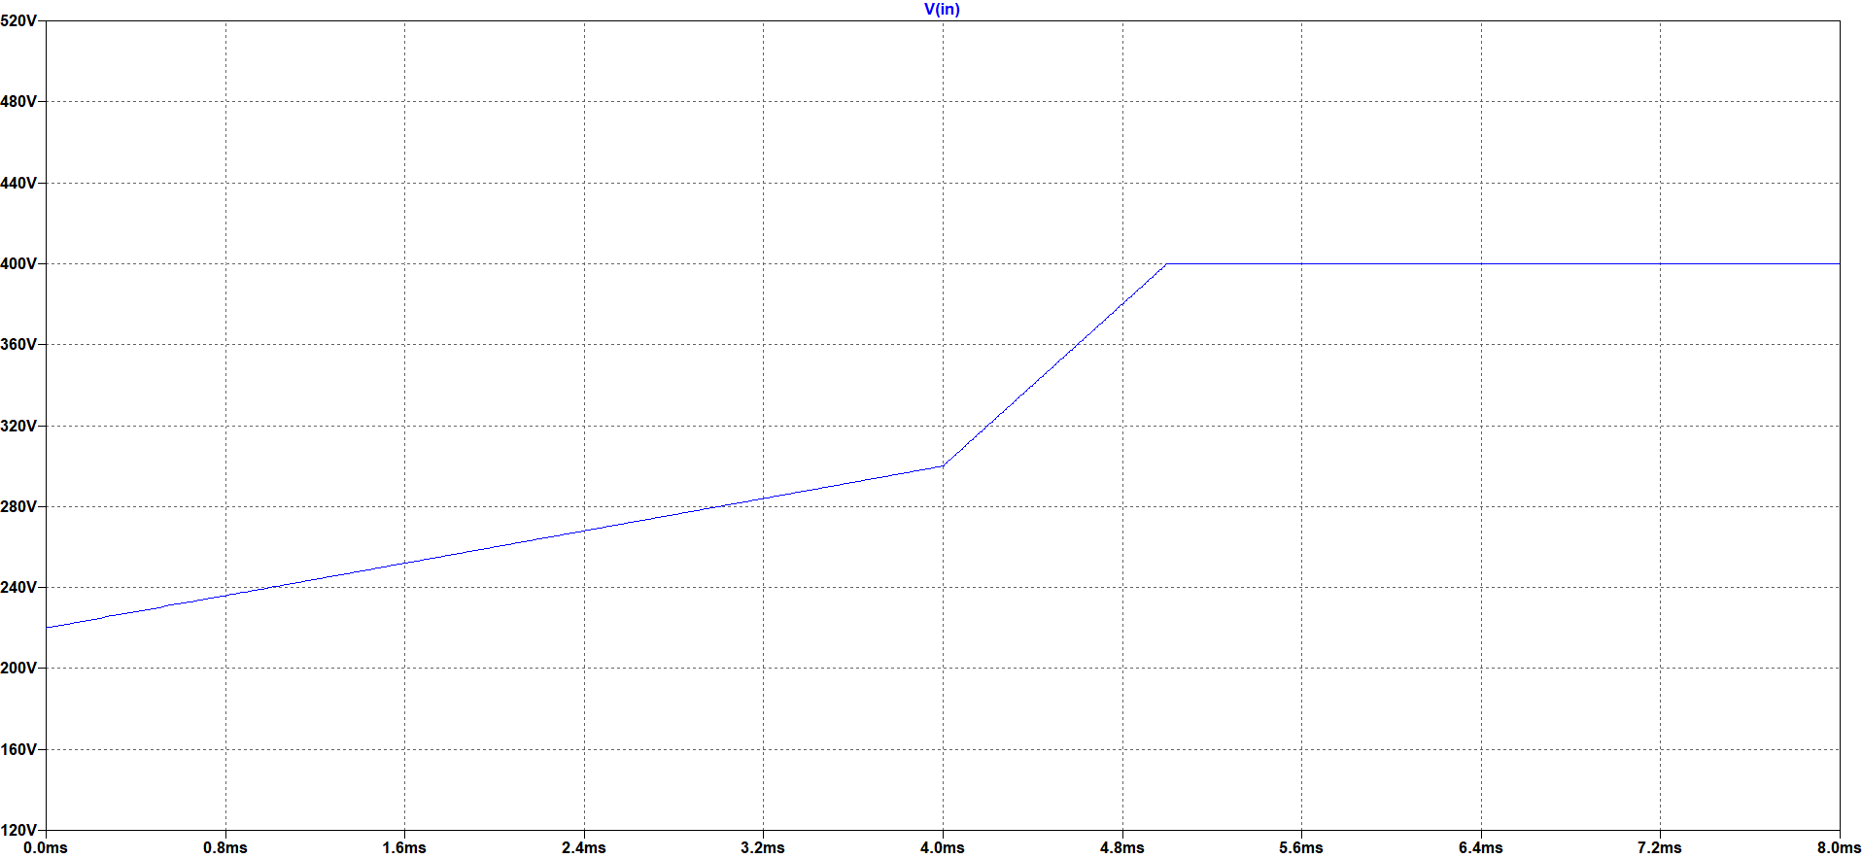

Figure Varying Input Voltage

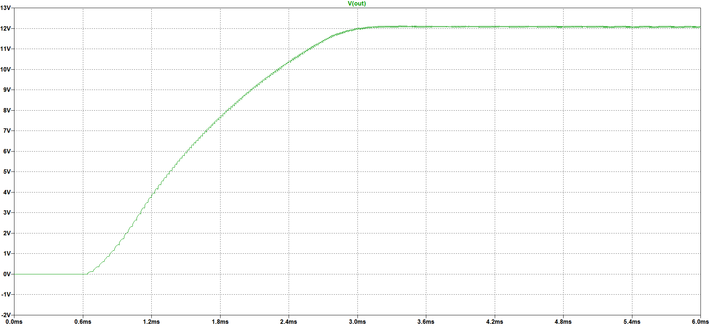

Figure Output Voltage Performance for Varying Input Voltage

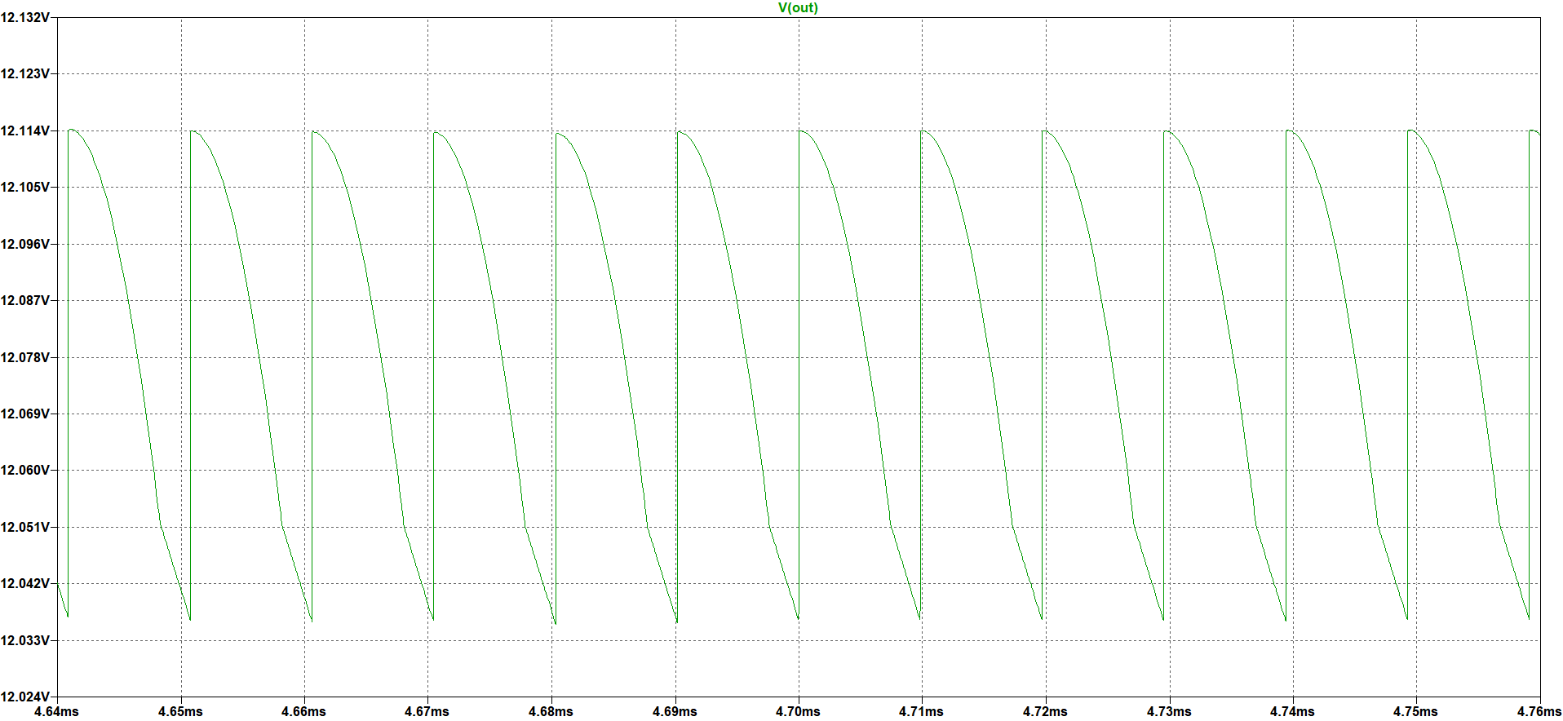

Figure Output Voltage Ripple for Varying Input Voltage

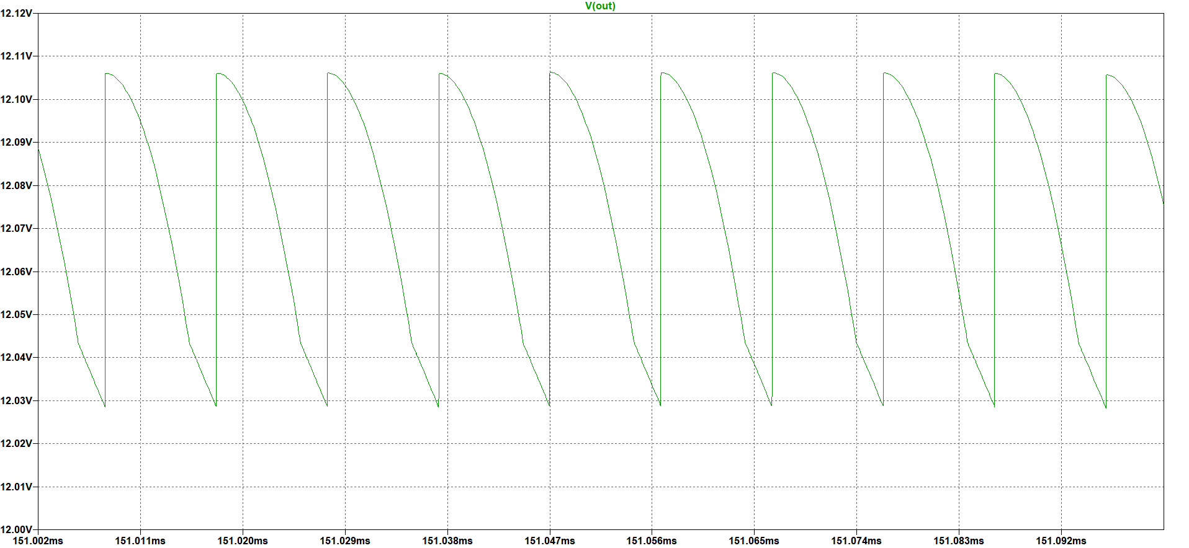

Figure Output Voltage Ripple for 220 V Input Voltage

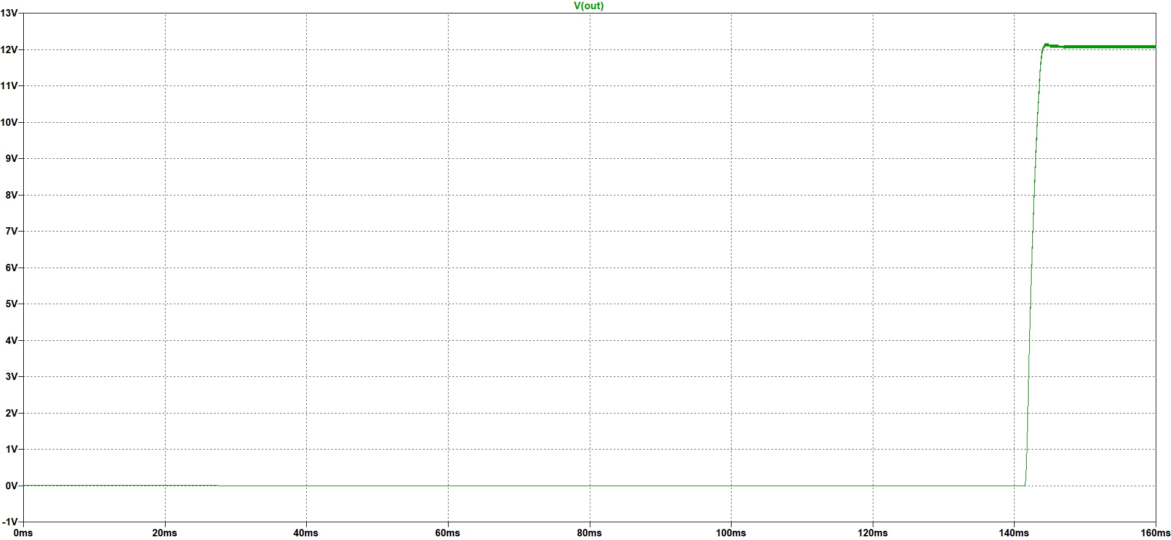

Figure Output Voltage for 220V Input Voltage

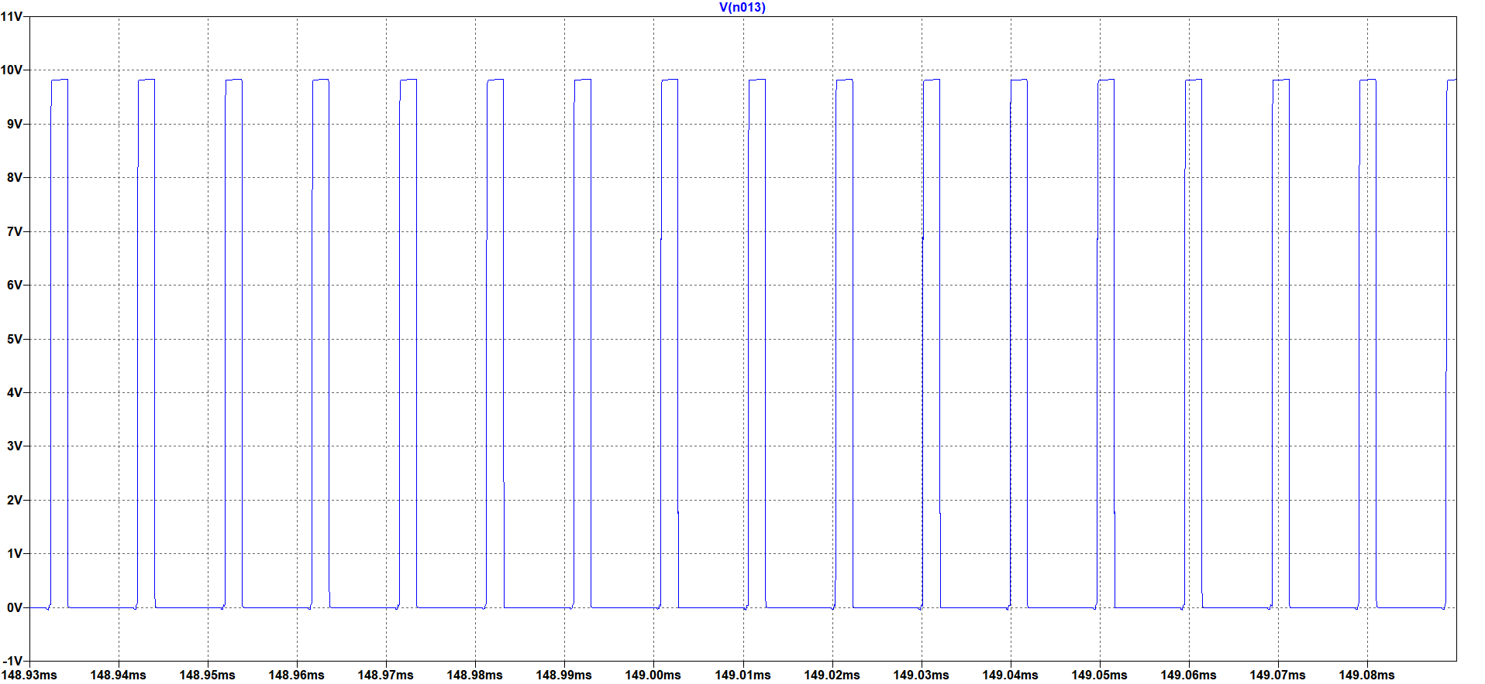

Figure MOSFET Gate Voltage for 220 V Input Voltage

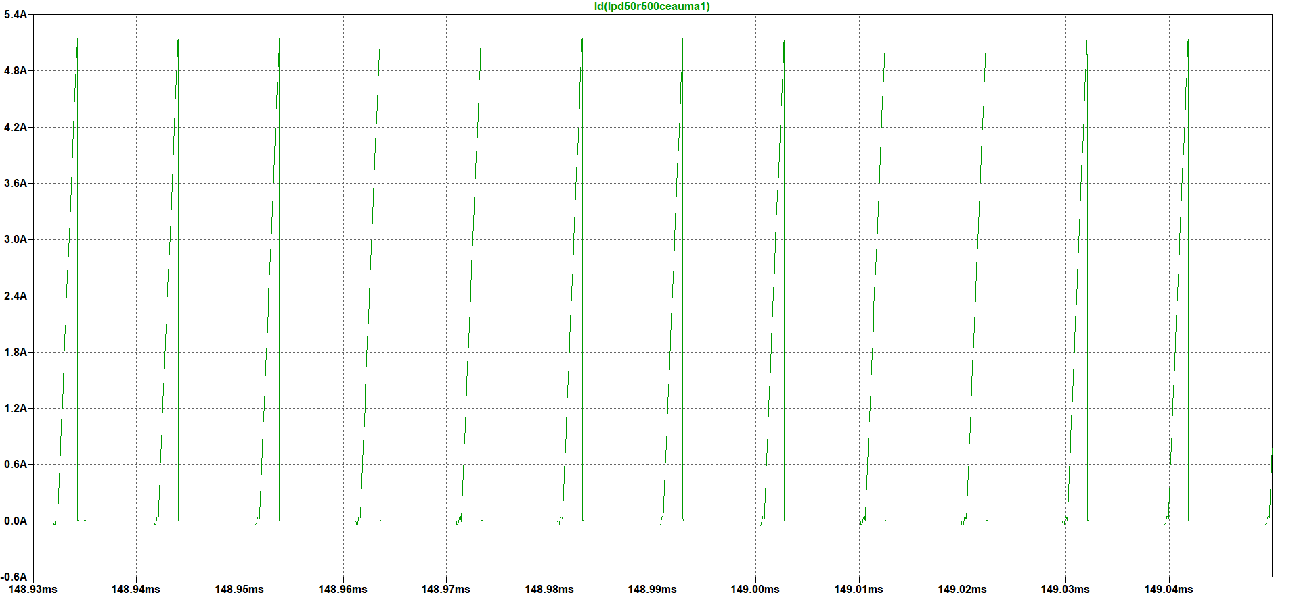

Figure MOSFET Current for 220 V Input Voltage

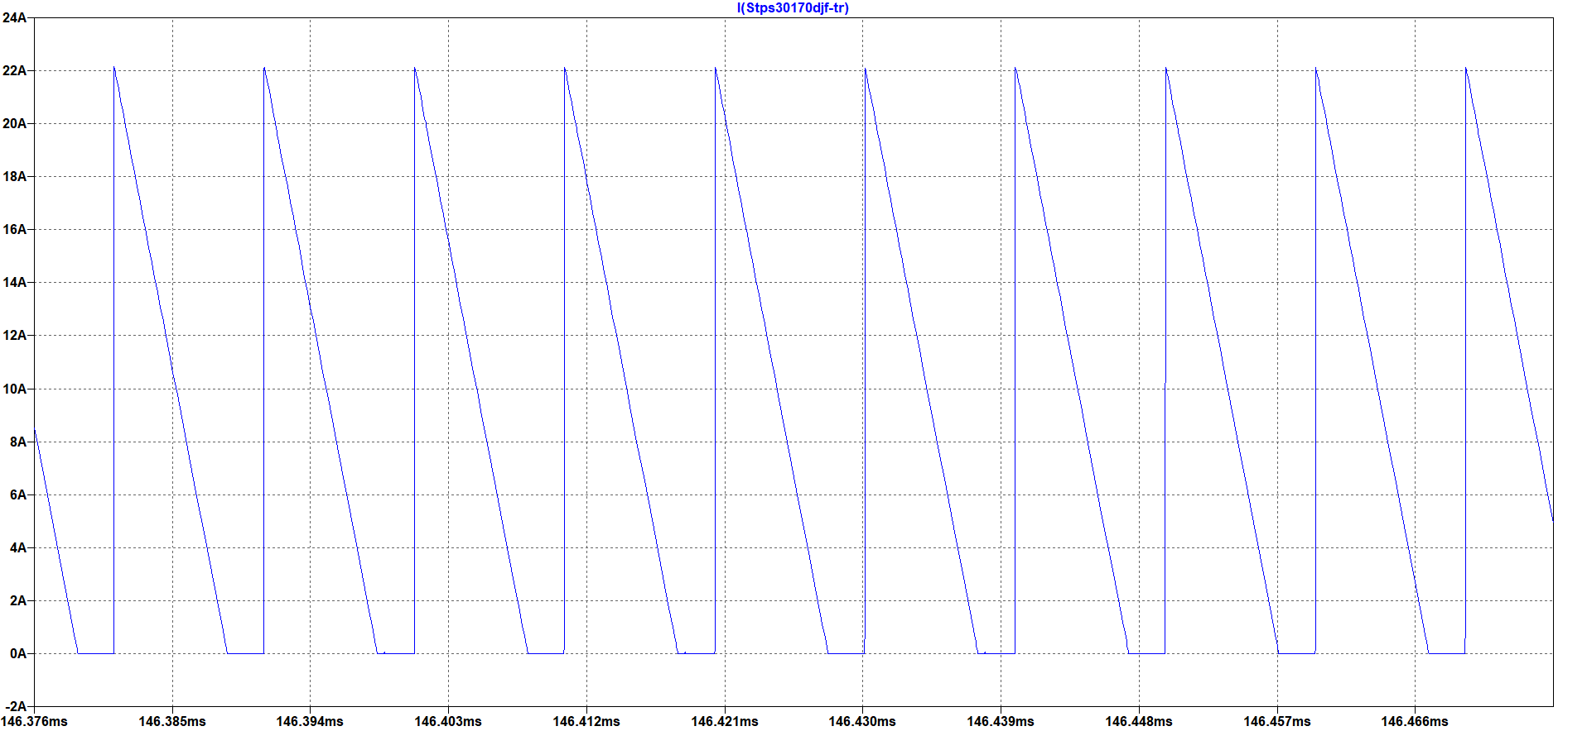

Figure Output Diode Current for 220 V Input Voltage

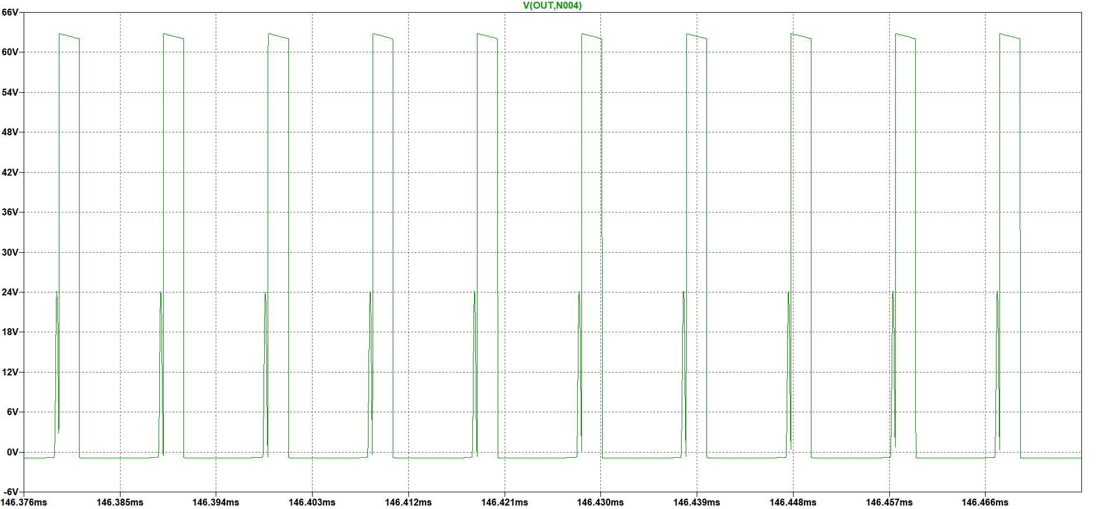

Figure Output Diode Voltage for 220 V Input Voltage

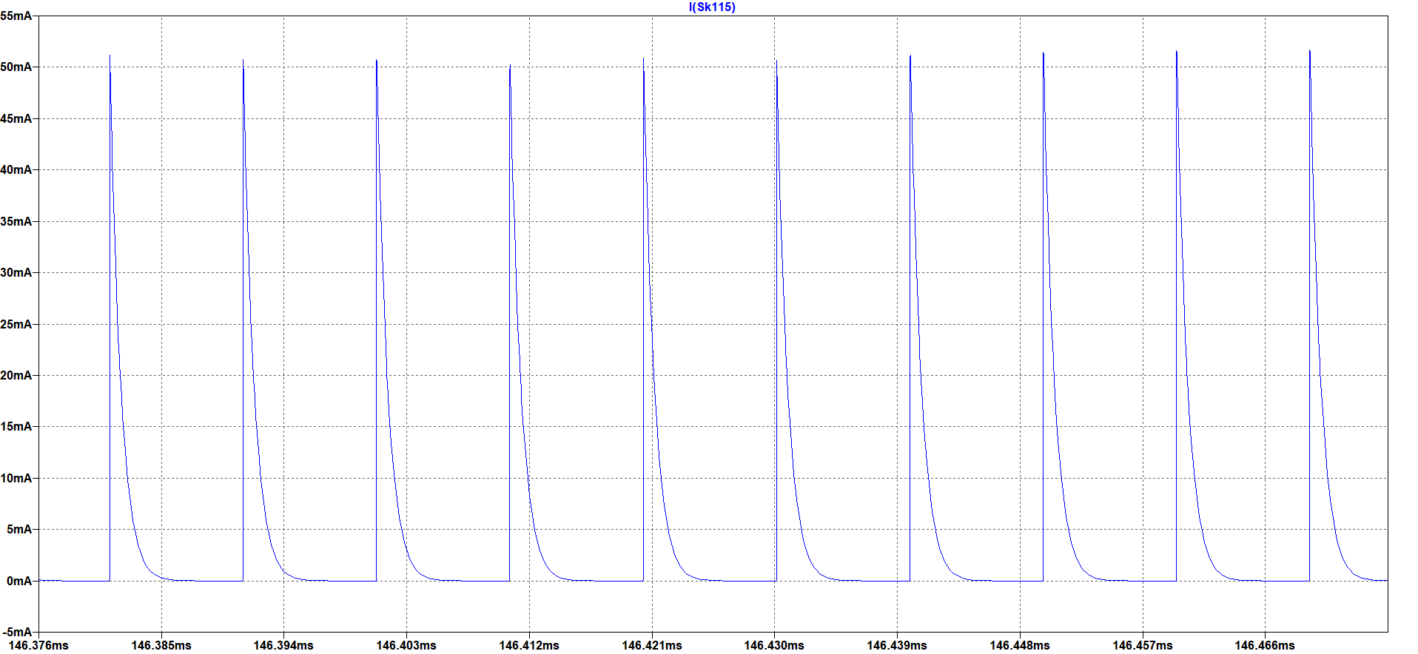

Figure Tertiary Diode Current for 220 V Input Voltage

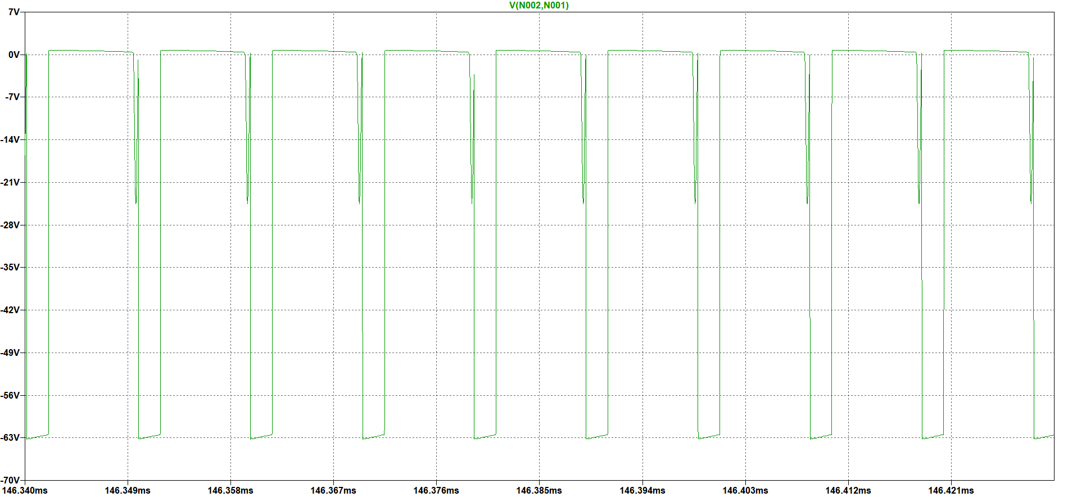

Figure Tertiary Diode Voltage for 220 V Input Voltage

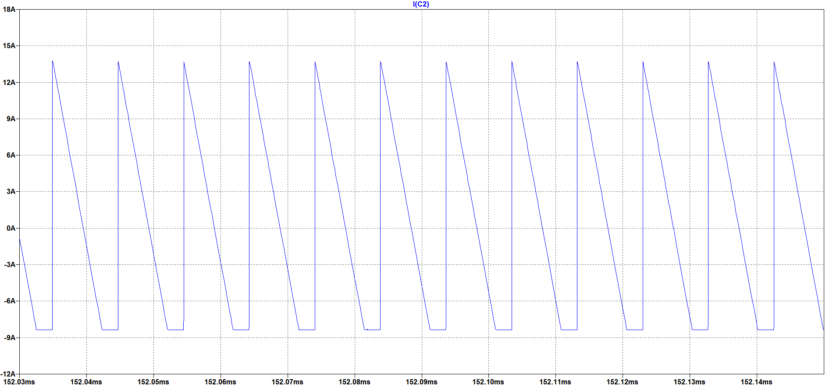

Figure Output Capacitor Current Ripple for 220 V Input Current

The voltage of output capacitor is the same as the output voltage.

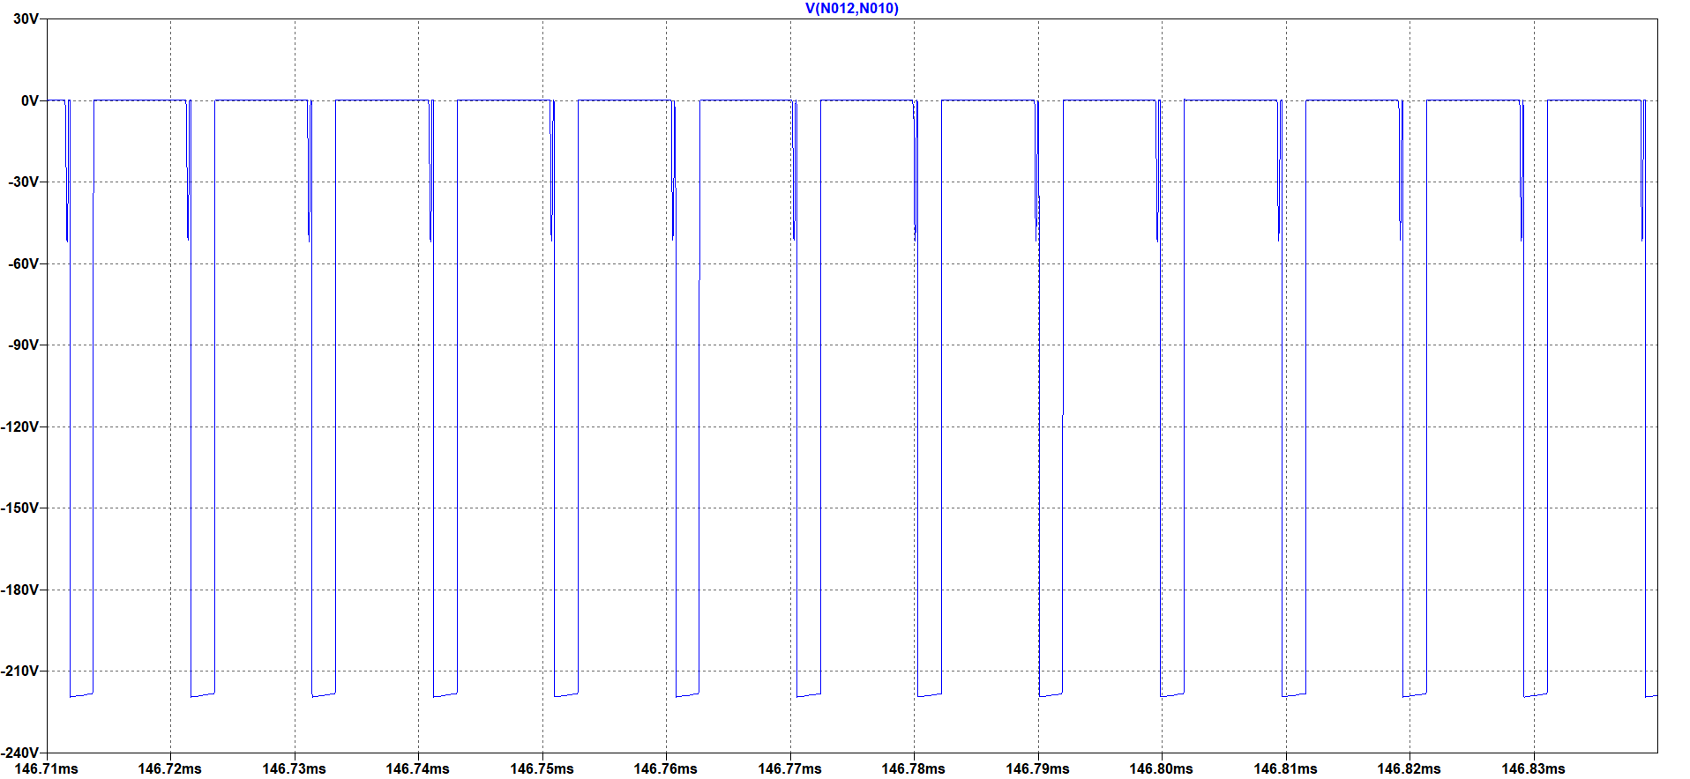

Figure Snubber Diode Voltage for 220 V Input Voltage

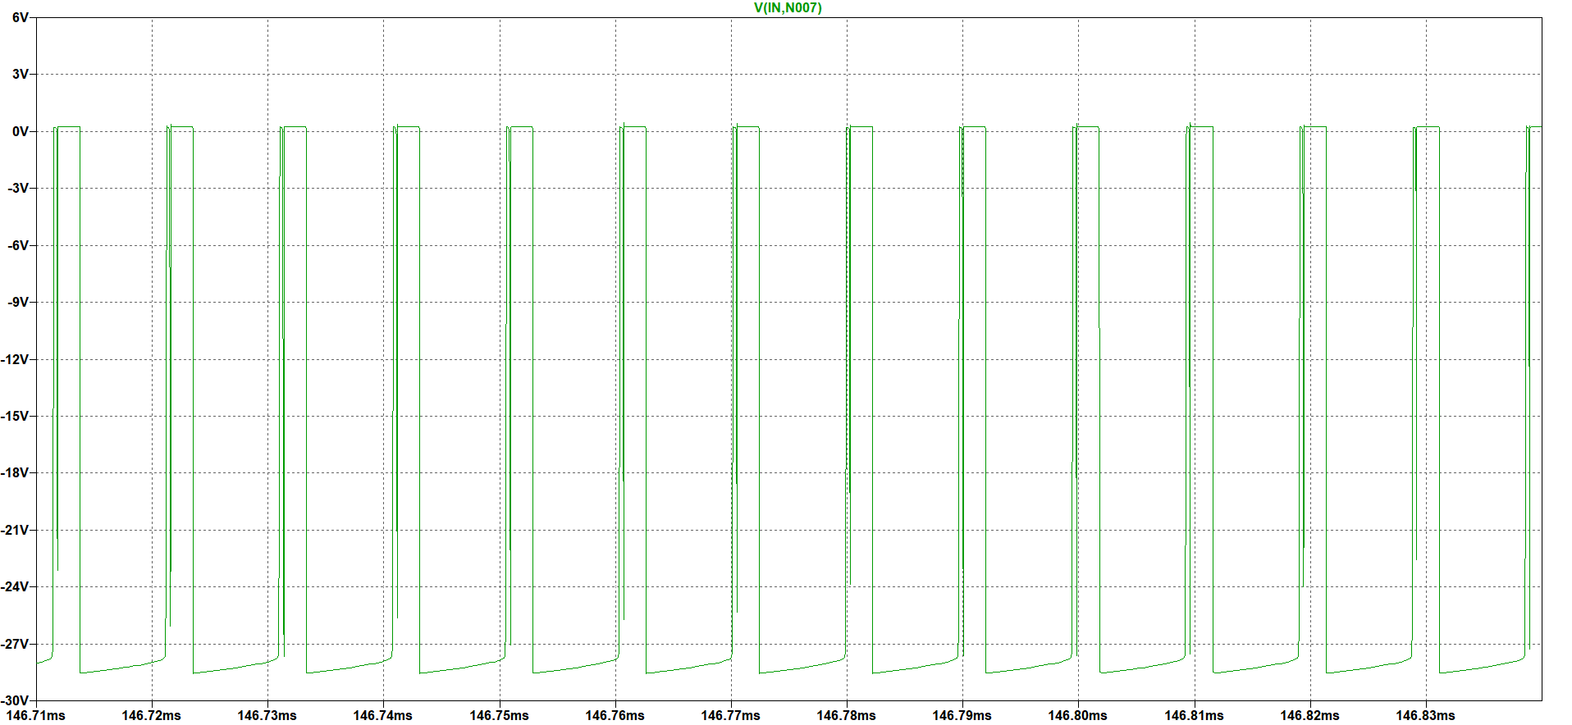

Figure Zener Diode Voltage for 220V Input Voltage

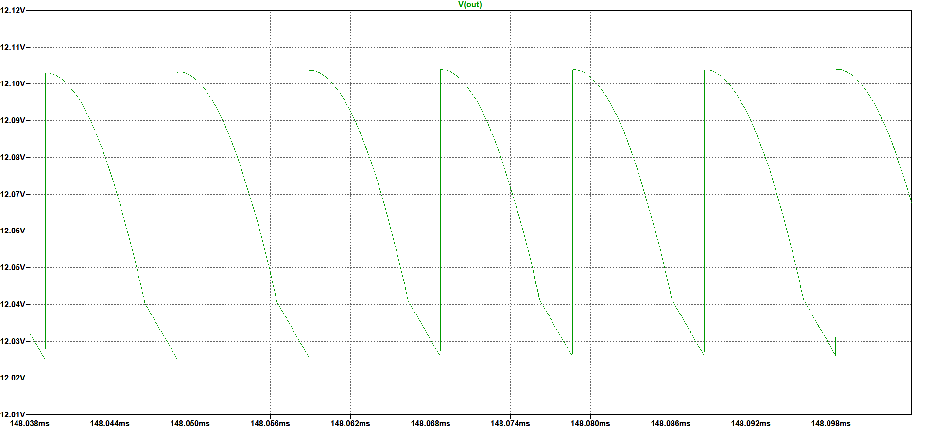

Figure Output Voltage Ripple for 400V Input Voltage

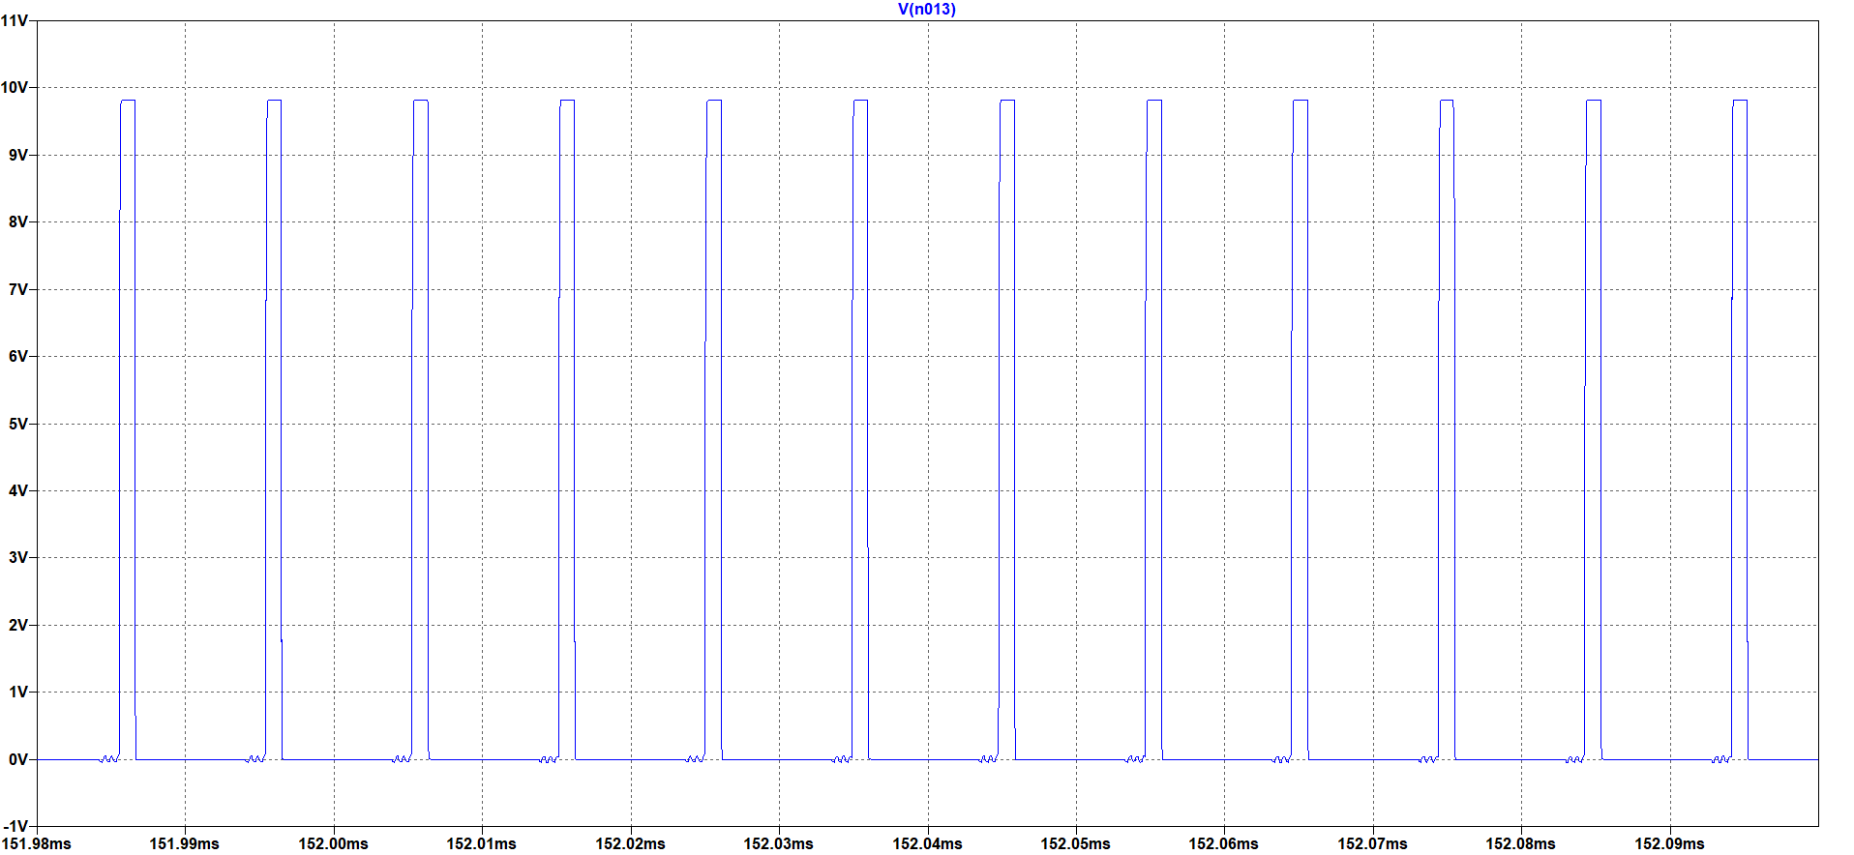

Figure MOSFET Gate Voltage for 400V Input Voltage

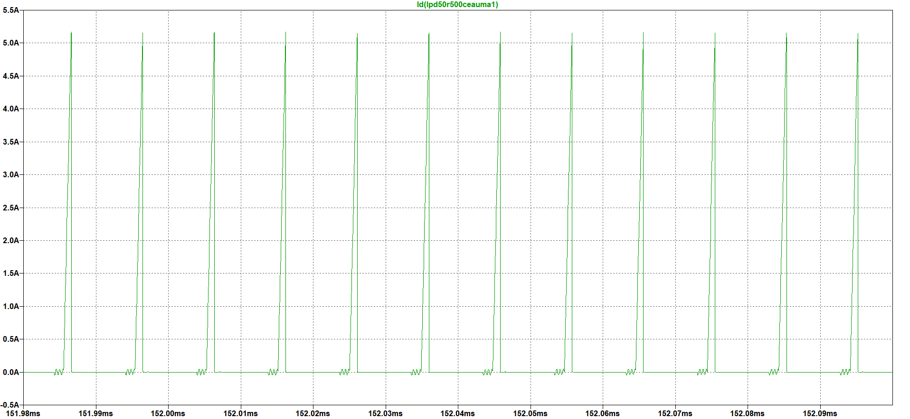

Figure MOSFET Current for 400V Input Voltage

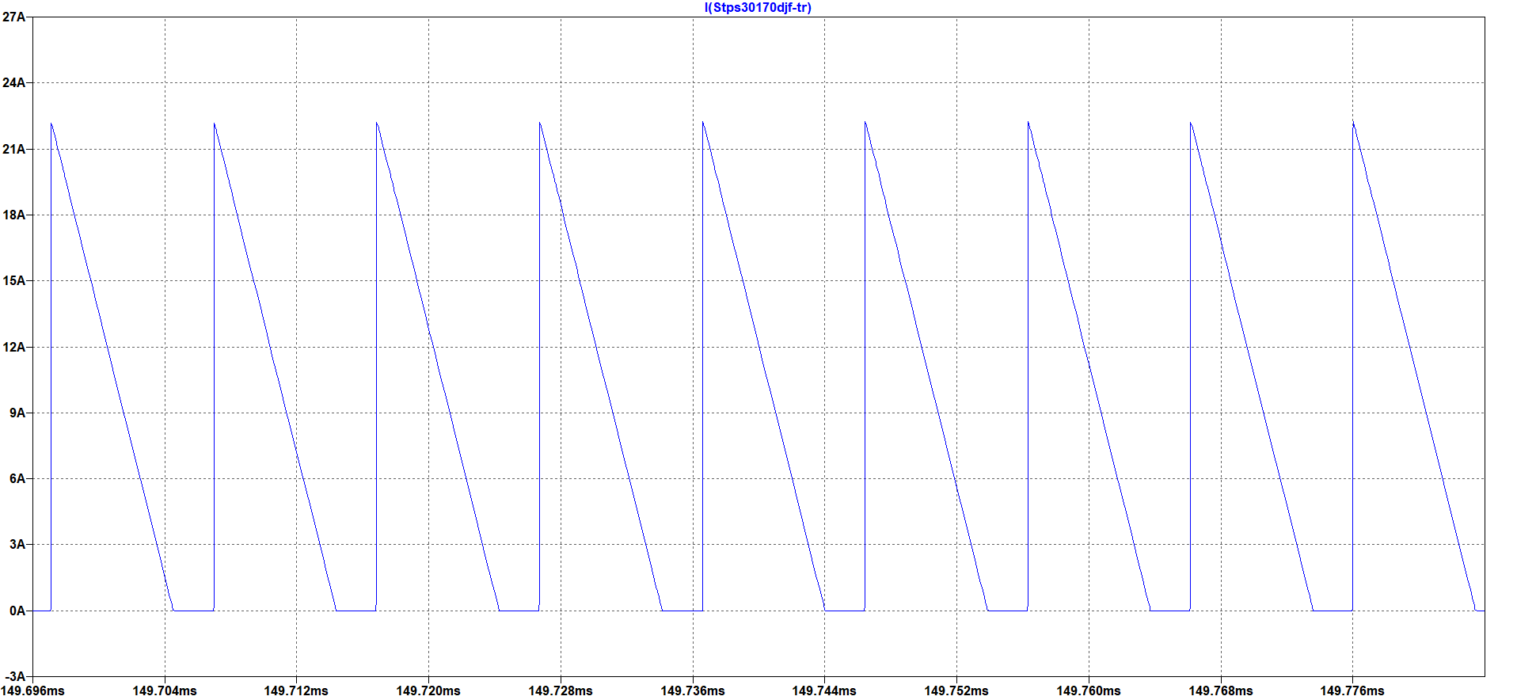

Figure Output Diode Current for 400 V Input Voltage

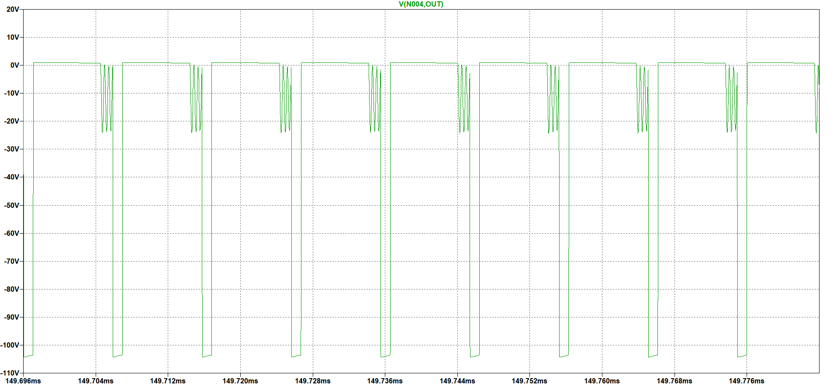

Figure Output Diode Voltage for 400V Input Voltage

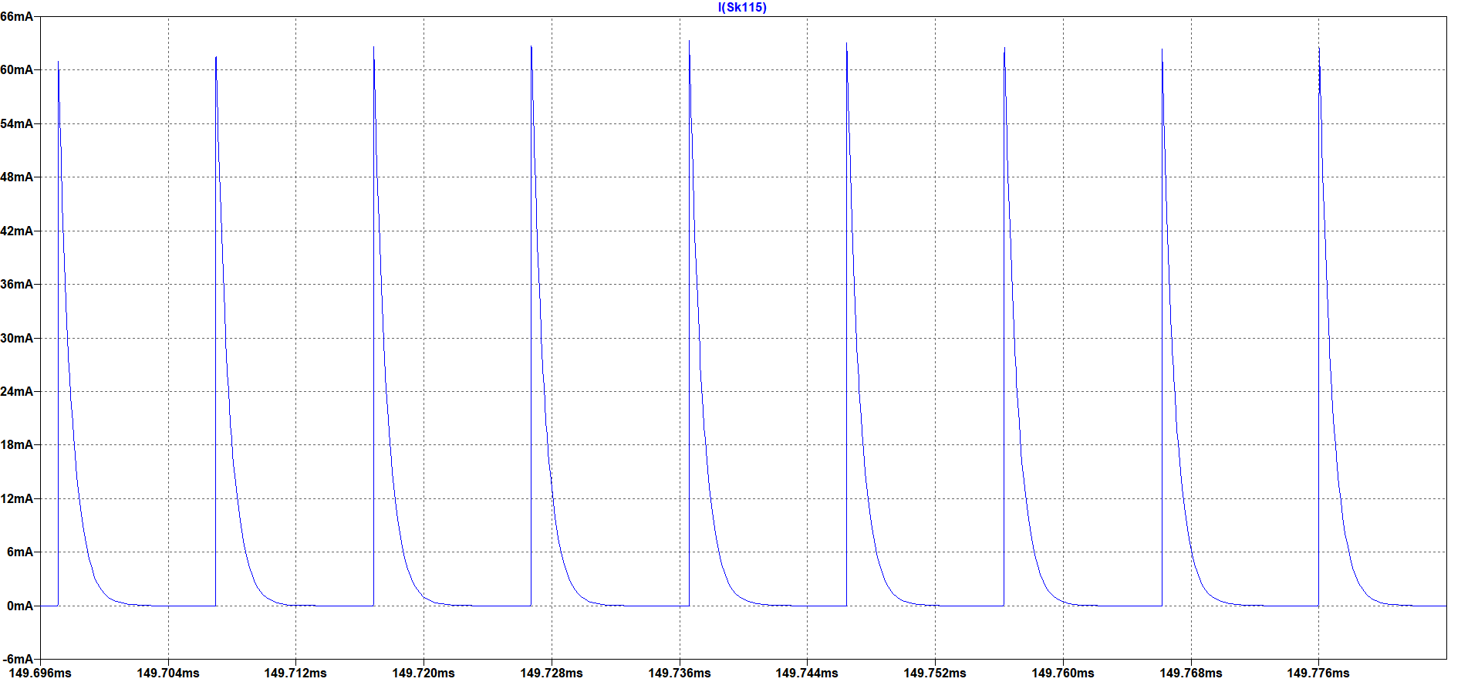

Figure Tertiary Diode Current for 400V Input Voltage

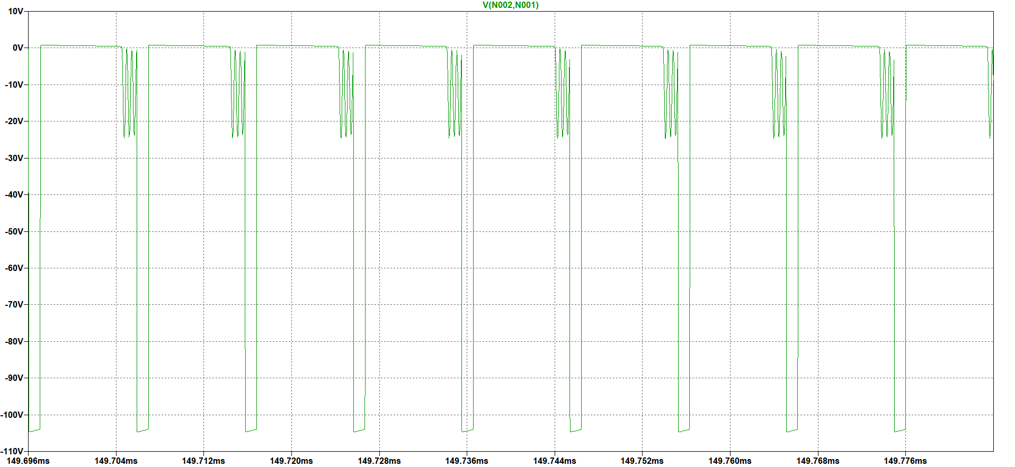

Figure Tertiary Diode Voltage for 400V Input Voltage

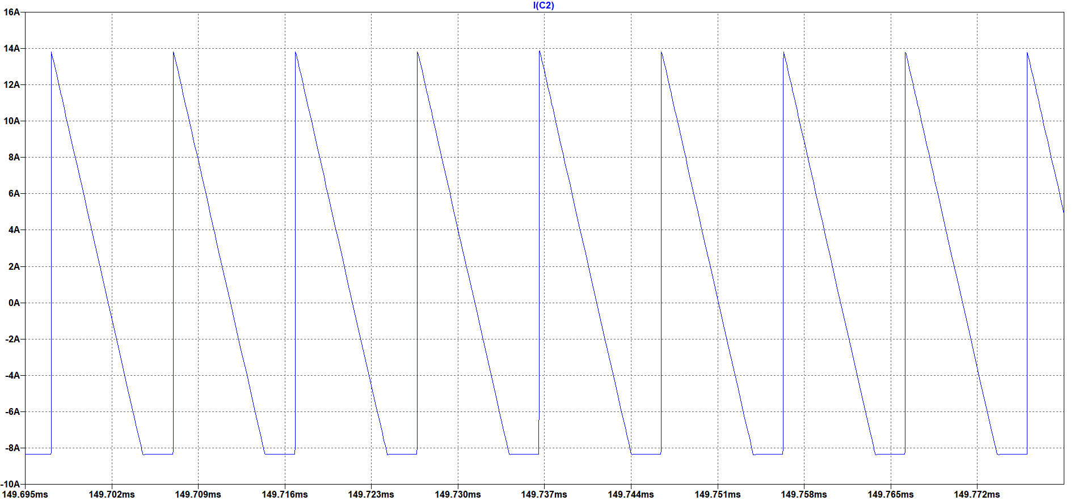

Figure Output Capacitor Current Ripple for 400V Input Voltage

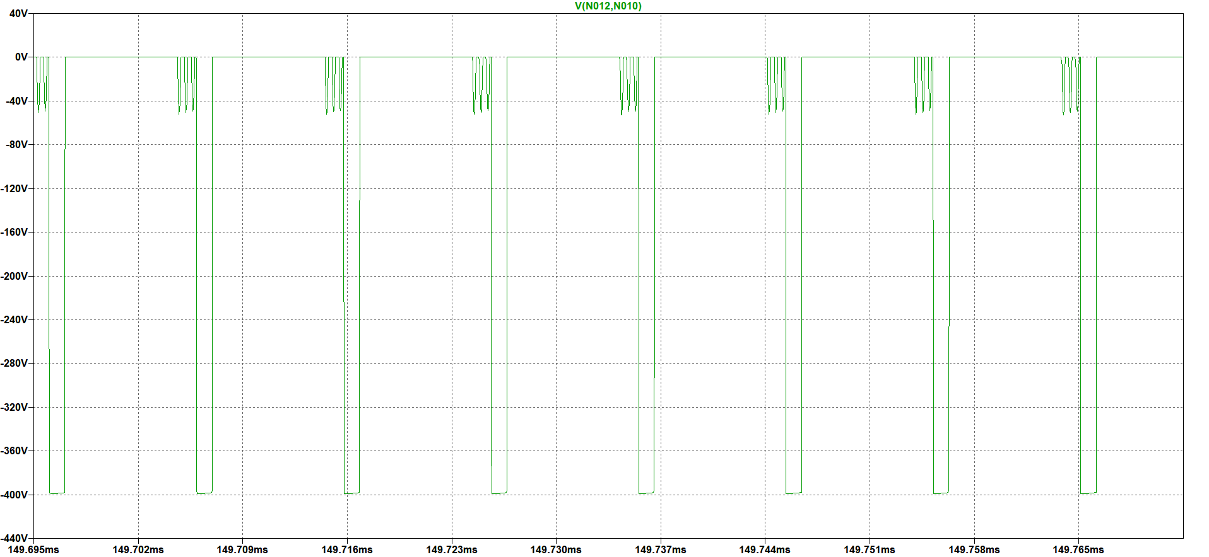

Figure Snubber Diode Voltage for 400V Input Voltage Ripple

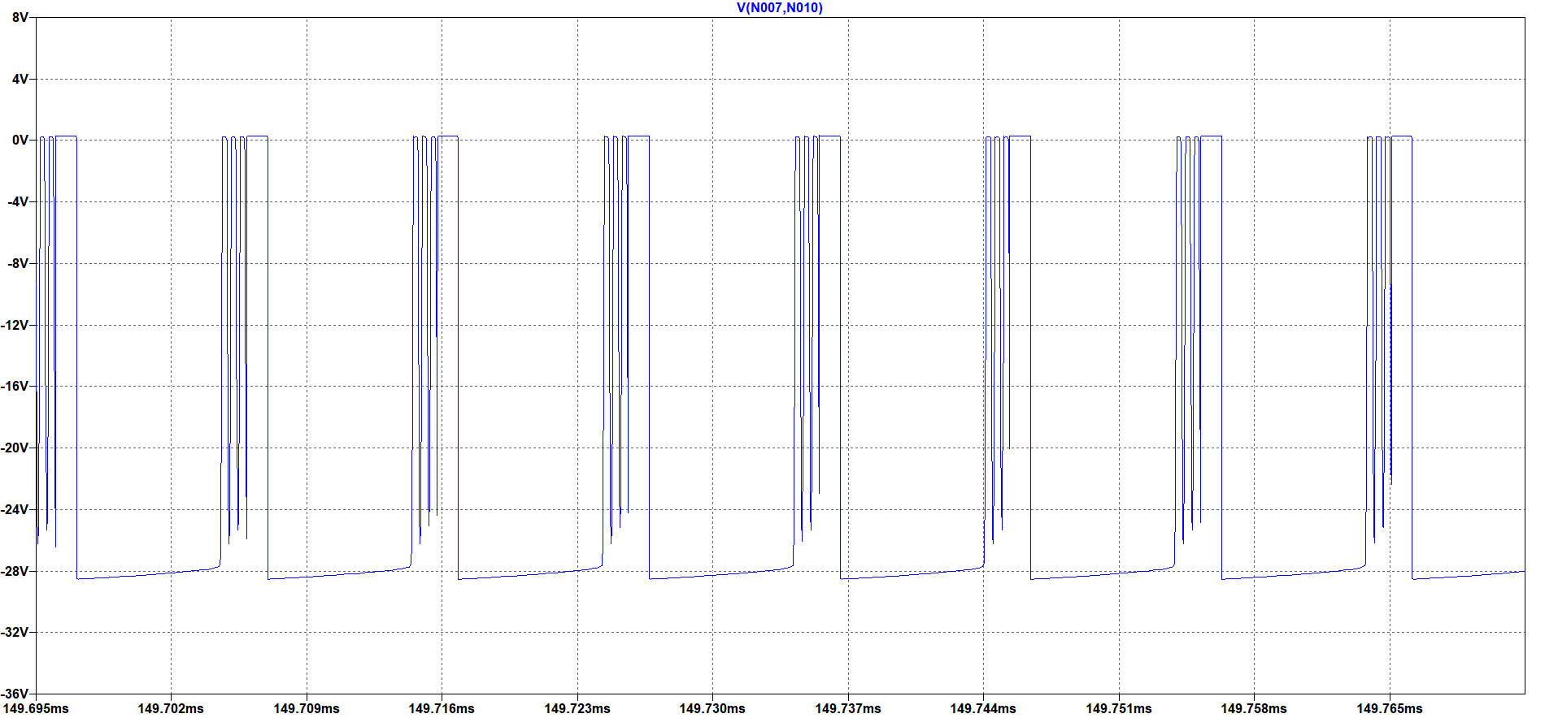

Figure Snubber Zener Diode Voltage for 400V Input Voltage Ripple